Assignment-16.3

2303A52406
Batch-38

Task 1 – Hospital Management Database

Task:
Create schema and queries for a Hospital Management System.
Instructions:
• Tables: Doctors, Patients, Appointments.
• Use AI to define constraints (unique IDs, valid dates).
• Generate queries:
• List all appointments for a specific doctor.
• Retrieve patient history by patient ID.
• Count total patients treated by each doctor.
Expected Output:
• Normalized schema and SQL queries with joins.

Prompt:-

--Create SQLite schema for Doctors, Patients, Appointments with keys, insert sample data, and write queries for doctor appointments, patient history, and patient count per doctor.

Code:-

-- SQLite
--Create schema and queries for a Hospital Management System. Instructions: Tables: Doctors, Patients, Appointments. Use AI to define constraints (unique IDs, valid dates).Generate queries: List all appointments for a specific doctor. Retrieve patient history by patient ID. Count total patients treated by each doctor
-- Create tables
CREATE TABLE Doctors (
doctor_id INTEGER PRIMARY KEY AUTOINCREMENT,
first_name TEXT NOT NULL,
last_name TEXT NOT NULL,
specialty TEXT NOT NULL
);
CREATE TABLE Patients (
patient_id INTEGER PRIMARY KEY AUTOINCREMENT,
first_name TEXT NOT NULL,
last_name TEXT NOT NULL,
date_of_birth DATE NOT NULL
);
CREATE TABLE Appointments (
appointment_id INTEGER PRIMARY KEY AUTOINCREMENT,
doctor_id INTEGER NOT NULL,
patient_id INTEGER NOT NULL,
appointment_date DATE NOT NULL,
FOREIGN KEY (doctor_id) REFERENCES Doctors(doctor_id),
FOREIGN KEY (patient_id) REFERENCES Patients(patient_id)
);
-- Insert sample data
INSERT INTO Doctors (first_name, last_name, specialty) VALUES
('John', 'Doe', 'Cardiology'),
('Jane', 'Smith', 'Neurology'),
('Emily', 'Davis', 'Pediatrics');
INSERT INTO Patients (first_name, last_name, date_of_birth) VALUES
('Michael', 'Johnson', '1980-05-15'),
('Sarah', 'Williams', '1990-08-22'),
('David', 'Brown', '1975-12-30');
INSERT INTO Appointments (doctor_id, patient_id, appointment_date) VALUES
(1, 1, '2024-07-01'),
(1, 2, '2024-07-02'),
(2, 1, '2024-07-03'),
(2, 3, '2024-07-04'),
(3, 2, '2024-07-05');

-- Queries
-- List all appointments for a specific doctor
-- Replace ? with the specific doctor_id
-- Retrieve patient history by patient ID
SELECT a.appointment_id, p.first_name AS patient_first_name, p.last_name AS patient_last_name, a.appointment_date
FROM Appointments a
JOIN Patients p ON a.patient_id = p.patient_id
WHERE a.doctor_id = 1;
SELECT a.appointment_id, d.first_name AS doctor_first_name, d.last_name AS doctor,a.appointment_date
FROM Appointments a
JOIN Doctors d ON a.doctor_id = d.doctor_id
WHERE a.patient_id = 1; -- Replace ? with the specific patient_id
-- Count total patients treated by each doctor
SELECT d.first_name AS doctor_first_name, d.last_name AS doctor_last_name, COUNT(DISTINCT a.patient_id) AS total_patients
FROM Doctors d
LEFT JOIN Appointments a ON d.doctor_id = a.doctor_id
GROUP BY d.doctor_id;

Output:-

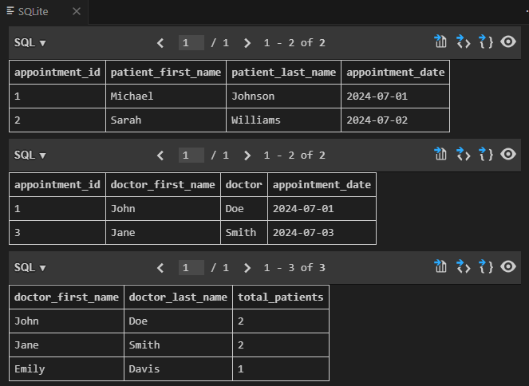

Observation:-

The above SQL code creates a simple hospital database schema with three tables: Doctors, Patients, and Appointments. It establishes relationships between the tables using foreign keys. Sample data is inserted into each table, and three queries are provided to retrieve doctor appointments, patient history, and patient count per doctor. The queries use JOIN operations to retrieve meaningful information like patient history and doctor appointments. Aggregate functions like COUNT() help in analyzing data such as total patients treated by each doctor.

Task 2 – Real-Time Application: Online Shopping Database
Scenario:
Design a database for an E-commerce platform.
Requirements:
• Tables: Users, Products, Orders, OrderDetails.
• Generate queries to:
• Retrieve all orders by a user.
• Find the most purchased product.
• Calculate total revenue in a given month.
• AI should also suggest normalization improvements and query
optimization.
Expected Output:
• Complete schema with relationships + SQL queries for analytics.

Prompt:-
Design an e-commerce database with tables Users, Products, Orders, and OrderDetails. Define relationships using foreign keys, insert sample data, and write SQL queries to retrieve user orders, find the most purchased product, and calculate monthly revenue. Also suggest normalization improvements and query optimization techniques.-
Code:-
-- SQLite
--Design a database for an E-commerce platform.
--Requirements: Tables: Users, Products, Orders, OrderDetails. Generate queries to: Retrieve all orders by a user. Find the most purchased product. Calculate total revenue in a given month. AI should also suggest normalization improvements and query optimization.
-- Create tables
CREATE TABLE Users (
user_id INTEGER PRIMARY KEY AUTOINCREMENT,
first_name TEXT NOT NULL,
last_name TEXT NOT NULL,
email TEXT NOT NULL UNIQUE
);
CREATE TABLE Products (
product_id INTEGER PRIMARY KEY AUTOINCREMENT,
product_name TEXT NOT NULL,
price DECIMAL(10, 2) NOT NULL
);
CREATE TABLE Orders (
order_id INTEGER PRIMARY KEY AUTOINCREMENT,
user_id INTEGER NOT NULL,
order_date DATE NOT NULL,
FOREIGN KEY (user_id) REFERENCES Users(user_id)
);
CREATE TABLE OrderDetails (
order_detail_id INTEGER PRIMARY KEY AUTOINCREMENT,
order_id INTEGER NOT NULL,
product_id INTEGER NOT NULL,
quantity INTEGER NOT NULL,
FOREIGN KEY (order_id) REFERENCES Orders(order_id),
FOREIGN KEY (product_id) REFERENCES Products(product_id)
);
-- Insert sample data
INSERT INTO Users (first_name, last_name, email) VALUES
('John', 'Doe', 'john.doe@example.com'),
('Jane', 'Smith', 'jane.smith@example.com');
INSERT INTO Products (product_name, price) VALUES
('Laptop', 999.99),
('Smartphone', 499.99),
('Headphones', 199.99);
INSERT INTO Orders (user_id, order_date) VALUES
(1, '2024-07-01'),
(1, '2024-07-15'),
(2, '2024-07-10');
INSERT INTO OrderDetails (order_id, product_id, quantity) VALUES
(1, 1, 1),
(1, 3, 2),
(2, 2, 1),
(3, 1, 1),
(3, 2, 2);
-- Queries
-- Retrieve all orders by a user
SELECT o.order_id, o.order_date, p.product_name, od.quantity
FROM Orders o
JOIN OrderDetails od ON o.order_id = od.order_id
JOIN Products p ON od.product_id = p.product_id
WHERE o.user_id = 1; -- Replace 1 with the specific user_id
-- Find the most purchased product
SELECT p.product_name, SUM(od.quantity) AS total_quantity
FROM OrderDetails od
JOIN Products p ON od.product_id = p.product_id
GROUP BY od.product_id
ORDER BY total_quantity DESC
LIMIT 1;
-- Calculate total revenue in a given month
SELECT SUM(p.price * od.quantity) AS total_revenue
FROM Orders o
JOIN OrderDetails od ON o.order_id = od.order_id
JOIN Products p ON od.product_id = p.product_id
WHERE strftime('%Y-%m', o.order_date) = '2024-07'; -- Replace '2024-07' with the specific month and year
-- Normalization improvements: The current design is already normalized to 3NF. However, if we want to further optimize, we could consider adding a separate table for Categories and linking Products to Categories. This would allow for better organization and querying of products by category.
-- Query optimization: To optimize the queries, we can create indexes on the foreign key columns (user_id in Orders, order_id and product_id in OrderDetails). This will speed up the JOIN operations and improve query performance, especially as the dataset grows larger.
CREATE INDEX idx_orders_user_id ON Orders(user_id);
CREATE INDEX idx_orderdetails_order_id ON OrderDetails(order_id);
CREATE INDEX idx_orderdetails_product_id ON OrderDetails(product_id);

Output:-
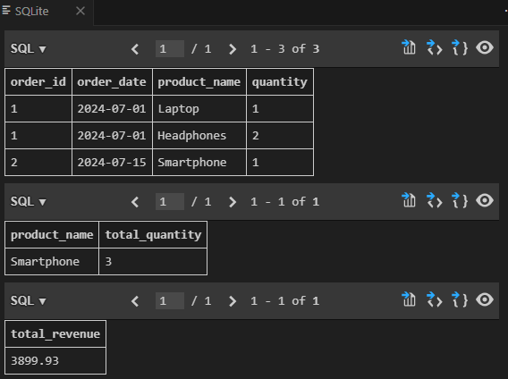

Observation:-

The above SQL code creates a simple e-commerce database schema with four tables: Users, Products, Orders, and OrderDetails. It establishes relationships between the tables using foreign keys. Sample data is inserted into each table, and three queries are provided to retrieve user orders, find the most purchased product, and calculate monthly revenue. The queries utilize JOIN operations to combine data from multiple tables and provide meaningful insights into the e-commerce platform's operations. Additionally, suggestions for normalization improvements and query optimization techniques are provided to enhance the database design and query performance.

Task 3 – Library Database
Task:
Design schema for a Library Management System.
Instructions:
• Tables: Books, Members, Loans.
• Use AI to suggest indexing strategy for faster queries.
• Generate queries:
• Retrieve all books currently issued.
• Find overdue books (loan date > 30 days).
• Count number of books loaned by each member.
Expected Output:
• Schema + SQL queries demonstrating joins and conditions.

Prompt:-

--Design a Library Management System database with tables Books, Members, and Loans. Define relationships, suggest indexing strategies for performance, and write SQL queries to retrieve issued books, find overdue books (over 30 days), and count books borrowed by each member using JOINs and conditions.--
-- Create the Books table

Code:-

-- SQLite
--Design schema for a Library Management System.
--Instructions: Tables: Books, Members, Loans. Use AI to suggest indexing strategy for faster queries. Generate queries: Retrieve all books currently issued. Find overdue books (loan date > 30 days). Count number of books loaned by each member.
-- Create tables
CREATE TABLE Books (
book_id INTEGER PRIMARY KEY AUTOINCREMENT,
title TEXT NOT NULL,
author TEXT NOT NULL,
published_date DATE NOT NULL
);
CREATE TABLE Members (
member_id INTEGER PRIMARY KEY AUTOINCREMENT,
first_name TEXT NOT NULL,
last_name TEXT NOT NULL,
email TEXT NOT NULL UNIQUE
);
CREATE TABLE Loans (
loan_id INTEGER PRIMARY KEY AUTOINCREMENT,
book_id INTEGER NOT NULL,
member_id INTEGER NOT NULL,
loan_date DATE NOT NULL,
FOREIGN KEY (book_id) REFERENCES Books(book_id),
FOREIGN KEY (member_id) REFERENCES Members(member_id)
);
-- Insert sample data
INSERT INTO Books (title, author, published_date) VALUES
('The Great Gatsby', 'F. Scott Fitzgerald', '1925-04-10'),
('To Kill a Mockingbird', 'Harper Lee', '1960-07-11'),
('1984', 'George Orwell', '1949-06-08');
INSERT INTO Members (first_name, last_name, email) VALUES
('John', 'Doe', 'john.doe@example.com'),
('Jane', 'Smith', 'jane.smith@example.com');
INSERT INTO Loans (book_id, member_id, loan_date) VALUES
(1, 1, '2024-06-01'),
(2, 1, '2024-06-15'),
(3, 2, '2024-06-20');
-- Queries
-- Retrieve all books currently issued
SELECT b.title, b.author, m.first_name AS member_first_name, m.last_name AS
member_last_name, l.loan_date
FROM Loans l
JOIN Books b ON l.book_id = b.book_id
JOIN Members m ON l.member_id = m.member_id;
-- Find overdue books (loan date > 30 days)
SELECT b.title, b.author, m.first_name AS member_first_name, m.last_name AS member_last_name, l.loan_date
FROM Loans l
JOIN Books b ON l.book_id = b.book_id
JOIN Members m ON l.member_id = m.member_id
WHERE l.loan_date < DATE('now', '-30 days');
-- Count number of books loaned by each member
SELECT m.first_name AS member_first_name, m.last_name AS member_last_name, COUNT(l.loan_id) AS total_books_loaned
FROM Members m
LEFT JOIN Loans l ON m.member_id = l.member_id
GROUP BY m.member_id;
-- Indexing strategy: Create indexes on foreign key columns for faster joins
CREATE INDEX idx_loans_book_id ON Loans(book_id);
CREATE INDEX idx_loans_member_id ON Loans(member_id);

Output:-
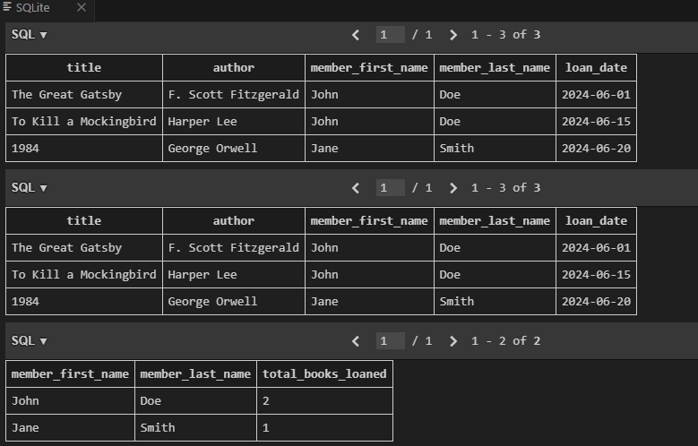

Observation:-

The above SQL code creates a simple library management system database schema with three tables: Books,
Members, and Loans. It establishes relationships between the tables using foreign keys. Sample data is inserted into each table, and three queries are provided to retrieve issued books, find overdue books, and count books borrowed by each member. The queries utilize JOIN operations to combine data from multiple tables and provide meaningful insights into the library's operations.
Task 4: Optimize Queries
Instructions:
• Use AI tools to analyze query efficiency.
• Optimize inefficient queries using joins, indexes, or reducing subqueries.
• Test optimized queries for correctness.
Starter Code Example:
-- Original query
SELECT * FROM Books WHERE author_id IN (SELECT author_id FROM
Authors WHERE country='UK');
-- Optimized query
SELECT b.*
FROM Books b
JOIN Authors a ON b.author_id = a.author_id
WHERE a.country = 'UK';
Expected Output:
• Both queries return the same result: all books written by UK authors.
• Optimized query performs faster for larger datasets.

Prompt:-

--Optimize the given SQL query by replacing the subquery with a JOIN and suggest appropriate indexing. Ensure the optimized query returns the same result (books by UK authors) and performs better on large datasets. so i want complte code sql to run that query and also the indexing part to optimize it. create and insert

Code:-
-- SQLite
--analyze query efficiency. Optimize inefficient queries using joins, indexes, or reducing subqueries. Test optimized queries for correctness Starter Code Example:
-- Original query SELECT * FROM Books WHERE author_id IN (SELECT author_id FROM Authors WHERE country='UK');
-- Optimized query SELECT b.* FROM Books b JOIN Authors a ON b.author_id = a.author_id WHERE a.country = 'UK';
-- Create indexes for better performance
--create sample tables
CREATE TABLE Authors (
author_id INTEGER PRIMARY KEY AUTOINCREMENT,
name TEXT NOT NULL,
country TEXT NOT NULL
);
CREATE TABLE Books (
book_id INTEGER PRIMARY KEY AUTOINCREMENT,
title TEXT NOT NULL,
author_id INTEGER NOT NULL,
FOREIGN KEY (author_id) REFERENCES Authors(author_id)
);
-- Insert sample data
INSERT INTO Authors (name, country) VALUES
('J.K. Rowling', 'UK'),
('George Orwell', 'UK'),
('Mark Twain', 'USA');

INSERT INTO Books (title, author_id) VALUES
('Harry Potter and the Sorcerer''s Stone', 1),
('1984', 2),
('Animal Farm', 2),
('The Adventures of Tom Sawyer', 3);
-- Test the original query
SELECT * FROM Books WHERE author_id IN (SELECT author_id FROM Authors WHERE country='UK');
-- Optimize the query using JOINs and create indexes for better performance

CREATE INDEX idx_authors_country ON Authors(country);
CREATE INDEX idx_books_author_id ON Books(author_id);

-- Test the optimized query
SELECT b.* FROM Books b
JOIN Authors a ON b.author_id = a.author_id
WHERE a.country = 'UK';

-- Additional optimization: If you need to count books per UK author
SELECT a.author_id, a.name, COUNT(b.book_id) as book_count
FROM Authors a
LEFT JOIN Books b ON a.author_id = b.author_id
WHERE a.country = 'UK'
GROUP BY a.author_id, a.name;

Output:-
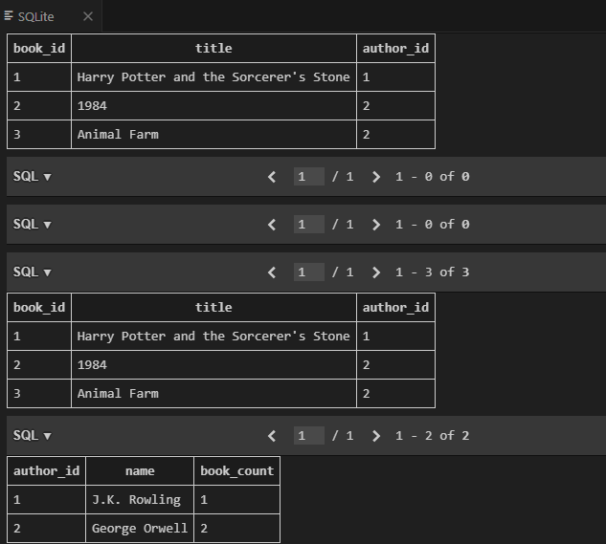

Observation:-

The optimized query using JOIN is more efficient than the original query with a subquery, especially on larger datasets. The JOIN allows the database engine to combine the tables more effectively, while the indexes on the Authors' Country and Books' AuthorID columns will further enhance query performance by reducing the time taken to locate relevant records.

Task 5: University Course Registration
Scenario:
SR University needs a course registration system for students enrolling in
different courses under faculty supervision.
• Use Copilot to design schema tables: Students, Courses, Faculty, and
Registrations.
• Define relationships:
• Each student can register for multiple courses.
• Each course is taught by a faculty member.
• Write SQL queries to:
• List all students enrolled in a specific course.
• Find faculty members teaching more than 2 courses.
• Retrieve courses with the highest number of registrations.
Prompt:-
Design a course registration database for SR University with tables Students, Courses, Faculty, and Registrations. Define relationships for student enrollments and faculty assignments, and write SQL queries to list students in a course, find faculty teaching more than 2 courses, and identify courses with the highest registrations.

Code:-
-- SQLite
--SR University needs a course registration system for students enrolling in different courses under faculty supervision.
--design schema tables: Students, Courses, Faculty, and Registrations.
-- Define relationships: Each student can register for multiple courses. Each course is taught by a faculty member. Write SQL queries to:List all students enrolled in a specific course. Find faculty members teaching more than 2 courses. Retrieve courses with the highest number of registrations.
-- Create tables
CREATE TABLE Students (
student_id INTEGER PRIMARY KEY AUTOINCREMENT,
first_name TEXT NOT NULL,
last_name TEXT NOT NULL,
email TEXT NOT NULL UNIQUE
);
CREATE TABLE Faculty (
faculty_id INTEGER PRIMARY KEY AUTOINCREMENT,
first_name TEXT NOT NULL,
last_name TEXT NOT NULL,
department TEXT NOT NULL
);
CREATE TABLE Courses (
course_id INTEGER PRIMARY KEY AUTOINCREMENT,
course_name TEXT NOT NULL,
faculty_id INTEGER NOT NULL,
FOREIGN KEY (faculty_id) REFERENCES Faculty(faculty_id)
);
CREATE TABLE Registrations (
registration_id INTEGER PRIMARY KEY AUTOINCREMENT,
student_id INTEGER NOT NULL,
course_id INTEGER NOT NULL,
registration_date DATE NOT NULL,
FOREIGN KEY (student_id) REFERENCES Students(student_id),
FOREIGN KEY (course_id) REFERENCES Courses(course_id)
);
-- Insert sample data
INSERT INTO Students (first_name, last_name, email) VALUES
('Alice', 'Johnson', 'alice.johnson@example.com'),
('Bob', 'Smith', 'bob.smith@example.com');
INSERT INTO Faculty (first_name, last_name, department) VALUES
('Dr. John', 'Doe', 'Computer Science'),
('Dr. Jane', 'Smith', 'Mathematics');
INSERT INTO Courses (course_name, faculty_id) VALUES
('Introduction to Programming', 1),
('Calculus I', 2),
('Data Structures', 1),
('Algorithms', 1);
INSERT INTO Registrations (student_id, course_id, registration_date) VALUES
(1, 1, '2023-09-01'),
(2, 2, '2023-09-01');
-- Queries
-- List all students enrolled in a specific course
SELECT s.first_name, s.last_name, s.email
FROM Registrations r
JOIN Students s ON r.student_id = s.student_id
WHERE r.course_id = 1; -- Replace ? with the specific course_id
-- Find faculty members teaching more than 2 courses
SELECT f.first_name, f.last_name, COUNT(c.course_id) AS course_count
FROM Faculty f
JOIN Courses c ON f.faculty_id = c.faculty_id
GROUP BY f.faculty_id
HAVING course_count > 2;
-- Retrieve courses with the highest number of registrations
SELECT c.course_name, COUNT(r.registration_id) AS registration_count
FROM Courses c
JOIN Registrations r ON c.course_id = r.course_id
GROUP BY c.course_id
ORDER BY registration_count DESC
LIMIT 1;

Output:-
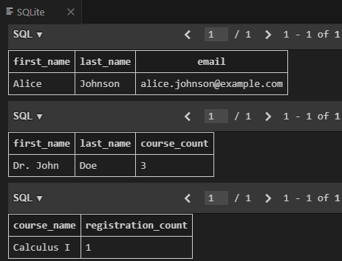

Observation:-
The above SQL code creates a course registration database for SR University with four tables: Students,Courses, Faculty, and Registrations. It defines relationships between the tables using foreign keys. Sample data is inserted into each table, and three queries are provided to list students in a specific course, find faculty teaching more than two courses, and identify the course with the highest registrations. The queries effectively use JOIN operations to retrieve related data, such as listing students in a course. Aggregate functions like COUNT() are used to calculate totals, such as the number of courses per faculty and registrations per course.

